

D5.1. Pilot course

Quality Assurance for the “Welding Technology: Testing and Quality Assurance” course

Erasmus +

Better Effect of Training (BET)

Project number 2020-1-SE01-KA202-077898,

______________________________________________________

This report includes information about the course evaluation and the course evaluation reports for the “Welding Technology: Testing and Quality Assurance” course, developed as pilot course within the BET project.

Circulation: Public distribution

Authors: Fabian Hanning/Asun Valiente

Version: 1.0

Stage: Draft

Date: 2023-05-23

The European Commission's support for the production of this publication does not constitute an endorsement of the contents, which reflect the views only of the authors, and the Commission cannot be held responsible for any use which may be made of the information contained therein

1. **Introduction:**

An essential tool for Quality Assurance at University West is the course evaluation. University West management offers students the opportunity to express their views on the courses via a course evaluation survey that is automatically posted in the Learning Management System before the course finishes. As soon as the course finishes, the course responsible gets the results of the survey and it is an obligation of the course responsible to compile the results of the course evaluation survey with any additional input received from teachers or students through other ways (i.e., interviews, focus group meetings or additional surveys) into a course evaluation report. The course evaluation report includes the analysis of the responses received, underlines strengths but most importantly those aspects to be improved, and it states the actions planned for the next course edition to implement improvements. The course evaluation report prepared by the course responsible must be shared with the students by uploading it to the Learning Management System no later than 5 weeks after the course is finished. The document is also stored at Department level for anyone in the organization to read it. Very importantly, it is presented and discussed at the Program Council where teachers and students are represented. The Program Council compiles an annual program report based on all course evaluation responses. This program report is presented and discussed in the department committee (IN). IN compiles all program reports in a department-wide quality report that is discussed in the research and education committee and is communicated to the department management and reported back to the program councils. The Research and Education Board (FUN) compiles the quality reports of all departments in a university-wide quality report which is communicated to the university's top management and is reported back to all department boards. This Quality Assurance process is illustrated in the figure below.

This pilot course was evaluated through interviews with the students after the completion of the first edition (2022), but also through interviews and course evaluation surveys in the second edition (2023).

In this document, the questions from the course evaluation survey, the questions raised in the interviews, and the course evaluation reports from 2022 and 2023 editions of the pilot course are presented. The document finishes with some discussion on the lessons learnt by having run these courses.

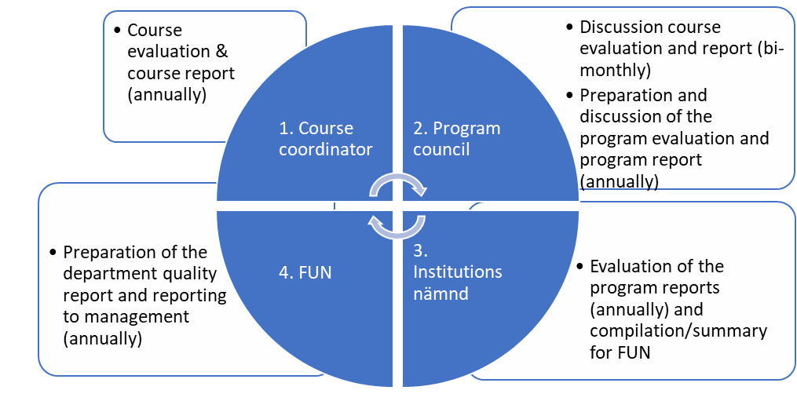

1. **Questions in the course evaluation survey**

The course evaluation survey contains two blocks of questions. The first block is common for all courses at university level, whilst the second block is specific for each department, in this case, for the Engineering department.

First block of questions (university level):

1. “Are you satisfied with the course?” Here the students can only choose among “yes” or “not”.
2. “What was good with the course?” This is an open question and students can explain themselves.
3. “What can be improved in the course?” Again, an open question for the students to explain their views.

Second block of questions (specific for the Engineering department):

* 1. “Has the information and organization of the course worked well?” The students must rate their responses from 1 to 5, being 1 the most negative and 5 the most positive.
  2. “Comments on the above” Open question where the students can elaborate on that specific aspect with their own explanations.
  3. “Were the teaching methods used in the course supporting my learning?” The students must rate their responses from 1 to 5, being 1 the most negative and 5 the most positive.
  4. “Comments on the above” Open question where the students can elaborate on that specific aspect with their own explanations.

6.1. “Was the exam well designed to show my knowledge in relation to the learning objectives of the course?” The students must rate their responses from 1 to 5, being 1 the most negative and 5 the most positive.

* 1. “Comments on the above” Open question where the students can elaborate on that specific aspect with their own explanations.

**3. Questions in the Focus group meeting**

The focus group meeting is chaired by a staff member, but neither teachers nor course coordinators are present, so that students can express themselves freely. The questions are divided into 5 topics and the students respond orally.

Theme 1: Communication and blended/online course format

a) How did you find this course?

b) Was the communication and information given before the start of the course clear and understandable?

c) Was the communication and information during the course clear and understandable?

(i.e., learning platforms (LMS/Canvas), web meetings, e-mail, etc.)

Theme 2: Pedagogical aspects, course format, course material and examination

a) Did the course structure/format increase your commitment to completing the course?

b) Was the pace of study balanced and manageable for professionals working full-time?

c) How has the training material worked? (e.g., instructions, exercises, literature, films, etc.)

d) How have the forms of the examination worked and have the examination tasks been at the right level? (e.g., labs, written and oral assignments, etc.)

Theme 3: Co-production

a) How have the teachers stimulated you to develop and share your own knowledge?

b) How have you learned from the other course participants?

c) Did the course facilitate new opportunities for future collaboration with other course participants? Give examples.

d) Did the course facilitate new opportunities for future collaboration with participating universities and their teachers? Give examples.

Theme 4: Transformation

a) Has the course topic been relevant to your work and work responsibilities?

b) Has the course given you the confidence to do more advanced work in the subject area?

c) What follow-up takes place at your company? To whom and how is your acquired knowledge shared? (i.e., business support).

d) Can you/you exemplify activities and methods for spreading knowledge in your company during and after the training?

Theme 5: Overarching issues and future outlook

a) What improvements can be made in this format for training?

b) Has the Covid-19 pandemic had an impact on the course, if so in what way and how was this dealt with?

c) Is there anything else you/you wish to add?

d) Would you recommend the course to a colleague/friend?

e) Which future course topics would interest you/you?

f) Is there interest/need for additional courses in this area (category)

g) During the course, have you identified an area in which you need to develop your skills?

h) What do you see is the next step after this course.

- What focus

- What orientation

**4. Course evaluation report, - 2022**

It includes the information received from the focus group meeting.

|  |  |
| --- | --- |
| **Kurskod, kursnamn**  *Course Code, Name of the Course* | SPK600 Welding Technology: Testing and Quality Assurance |
| **Program kursen ges på** *Programme* | BET |
| **Kursansvarig lärare**  *Course Coordinator* | Fabian Hanning |
| **Examinator** *Examiner* | Fabian Hanning |
| **Kurstillfälle** *Course Instance* | VT22 |
| **Campus/Distans**  *Campus/Distance Learning* | Blended (Distance with campus labs) |
| **Antal studenter på kursens Canvassida**  *Number of Students according to Canvas* | 5 |
| **Uppgiftslämnare/kursgranskare** *Information Provider* | Fabian Hanning / Asun Valiente |

|  |
| --- |
| **Kursvärdering – metod och svarsfrekvens/** Course Evaluation – Method and Response Rate Describe used evaluations (evaluation in the middle of the course, evaluation of various moments), method (mentimeter, EvaSys) and response rate. |
| Focus group interview without the presence of teachers at the last course session (4 participants, 80% response rate). |

|  |
| --- |
| **Studentsynpunkter i kursvärderingarna/** Student feedback from Course EvaluationShort summary of the students’ opinions and their proposals for change (based on quantitative results, text answers from course evaluations and views from student dialogues) |
| The students in the focus group meetings confirmed these positive aspects:   * Course content matches expectations * Time schedule with weekly meetings on Friday afternoon * Combination of pre-recorded lectures and discussions – high flexibility * Discussions with experts * Student discussions in breakout rooms   In order to improve the course, the students proposed to:   * Provide material for upcoming week already on Friday * Together with lectures provide some questions that can be used to reflect and prepare for weekly discussion session. * Some parts had too much depth – students then just focussed on parts that were relevant for their work. * Describe more clearly which parts of the provided learning material are optional and what parts are mandatory. * More case studies in lectures and discussions * Introduce welding symbols, drawings and more information on standards. |

|  |
| --- |
| **Kursansvarigs, lärarlagets och examinators analys/** Analysis from teachersShort summary and analysis of the teacher’s (or teachers’ and examiner’s) opinions and proposals for change. The students’ feedback should be related to the teacher’s/teachers’ experience. |
| **Styrkor/** Strenghts**:**  The course layout with weekly seminars where participants actively discuss issues directly related to lectures and welding in their companies.  **Utvecklingsförslag/planerade åtgärder/** Suggestions for development/planned actions**:**  Course material must be made available earlier and discussion questions must also be available on Canvas before the seminars. |

**5. Course evaluation report 2023**

Including the information received from the focus groups meeting and the course evaluation survey.

|  |  |
| --- | --- |
| **Kurskod, kursnamn**  *Course Code, Name of the Course* | SPK600 Welding Technology: Testing and Quality Assurance |
| **Program kursen ges på** *Programme* | BET |
| **Kursansvarig lärare**  *Course Coordinator* | Fabian Hanning |
| **Examinator** *Examiner* | Fabian Hanning |
| **Kurstillfälle** *Course Instance* | VT23 |
| **Campus/Distans**  *Campus/Distance Learning* | Blended (Distance with campus labs) |
| **Antal studenter på kursens Canvassida**  *Number of Students according to Canvas* | 6 |
| **Uppgiftslämnare/kursgranskare** *Information Provider* | Fabian Hanning / Asun Valiente |

|  |
| --- |
| **Kursvärdering – metod och svarsfrekvens/** Course Evaluation – Method and Response Rate Describe used evaluations (evaluation in the middle of the course, evaluation of various moments), method (mentimeter, EvaSys) and response rate. |
| Course evaluation via EvaSys (5 responses, 83% response rate) and a focus group without the presence of teachers at the last course session (2 participants, 33% response rate). |

|  |
| --- |
| **Studentsynpunkter i kursvärderingarna/** Student feedback from Course EvaluationShort summary of the students’ opinions and their proposals for change (based on quantitative results, text answers from course evaluations and views from student dialogues) |
| Everyone who answered the survey was satisfied with the course. Under what went well, the contents in the course and the teachers' commitment were mentioned.  The course's organization, teaching methods and examination were rated 5 (out of 5) in the survey. However, it was desired that course material would be available earlier (released every Friday for the coming course week) and that the questions discussed at the seminars would be available in advance. |

|  |
| --- |
| **Kursansvarigs, lärarlagets och examinators analys/** Analysis from teachers.  Short summary and analysis of the teacher’s (or teachers’ and examiner’s) opinions and proposals for change. The students’ feedback should be related to the teacher’s/teachers’ experience. |
| **Styrkor/** Strenghts**:**  The weekly seminars where participants actively discuss issues linked to lectures and welding in their companies.  **Utvecklingsförslag/planerade åtgärder/** Suggestions for development/planned actions**:**  Course material must be made available earlier and discussion questions must also be available on Canvas before the seminars. |

**6. Final discussion/outcomes/lessons learnt**

**a. Positive aspects in terms of course contents and course design for both course editions**

* In both course editions, the course content matched the expectations of these industrial students.
* The time schedule with weekly meetings for discussions on Fridays fitted well with working schedules and it was appreciated.
* The flexibility for the students to watch the recorded lectures during the working week at their own path.
* The possibility to discuss with expert teachers in the field.
* Good study environment and active/committed teachers in the course.

**b. Aspects that were improved from the first edition to the second edition:**

In the first edition of the course, the material for each week was released and available for the students at the start of the working week. The students suggested having access to the material the previous week, and for the second edition of the course, the material was released on Friday of the previous week. Still the students have requested for future editions to provide the material even earlier. We understand that the students want to plan their week in advance, but providing them with the course material more than one week in advance could deviate the focus of the students. It will be considered anyhow for future editions.

The students have demanded to have the questions before the seminars to be prepared beforehand. Here there are some pros, as the students can understand better which are the main learning objectives, and they can be better prepared for the discussion with the experts, but at the same time, we will lose the spontaneity of the discussions if all the questions for discussion are released in advance.

From the first edition to the second edition, some more contents about standards were included. However, the students still demand for more. This will be discussed internally and either a new course can be developed on that topic, or more contents will be offered in future editions.

**c. Foundation**

The roots of the University West foundation are tightly linked to the need for mechanical engineers in the local industry (i.e., SAAB, GKN -former Volvo Aero). Therefore, undergraduate studies and courses for professionals in mechanical engineering have been offered and developed in synergy with the industry since University West was founded in the nineties.

The needs of the industry surrounding us are rapidly changing and it makes us stay alert to identify potential new areas to be included in our educational programs for the following years. For us, the integration of theory and practice during the studies promotes deep learning [1] and authentic learning [2], leading to quality education. That connection between theory and practice also boosts the employability of the students after the completion of their programs and very importantly, it promotes their adaptability to future working places during their careers [3], [4].

We connect theory and practice in different ways in the design and delivery of the courses: the laboratory works, the assignments based on industrial problems, the internship periods and thesis work in collaboration with the industry are some clear examples of these types of activities.

Six companies were interviewed during IO1 (Awareness raising to VET providers and fabrication industry). After the series of interviews, it was concluded that:

* Formal education does not give enough background in welding (so VET is needed!)
* All the companies have onsite training (given by colleagues with more experience), and only a minority of companies have external training.
* Current pedagogic approaches are traditional (practical + some classroom). However, most of them would like to have e-learning platforms (especially motivated by the pandemic), but not all the companies are there yet.
* An important weakness for their internal training is the lack of time for the internal teachers to prepare/improve their courses and their lack of pedagogic skills.
* For most of the companies, harmonization in the welding-related education (IIW, EWF) is important.
* Current training is basically focused on fulfilling H&S regulations and personnel certifications, but future training wishes are related to automation, digitalization (Industry 4.0) & new welding processes (to boost their efficiency).

From these conversations we decided to cover the knowledge gap identified in terms of Welding Technology, and that complemented the training needed for the companies’ employees. We also listened to the preferred teaching mode, preparing a course that could be mainly given online to offer flexibility to the students and that can be combined with the working times for the participants.

The development of a course that identified clear knowledge gaps and the delivery of it in a flexible mode to maximize the participation of the attendees have been crucial in the success of this pilot course.

By following the same procedure that we have developed in the BET project: listening to the surrounding companies and working closely together to identify needs and develop courses, we are now in the process of developing a new vocational education program in welding automation, and we are also developing a new master in welding engineering. Our experience participating in the BET project has facilitated these new educational programs ahead.

[1] Entwistle, Noel. (2009). Teaching for understanding at university: Deep approaches and distinctive ways of thinking. London: Palgrave Macmillan (203 pages).

[2] Carbone A, Rayner GM, Ye J, et al. (2020) Connecting curricula content with career context: the value of engineering industry site visits to students, academics and industry. European Journal of Engineering Education 45(6). Taylor & Francis: 971–984. DOI: 10.1080/03043797.2020.1806787.

[3] Yorke, M. and Knight, P.T. (2006) Embedding Employability into the Curriculum: Learning & Employability Series 1. The Higher Education Academy, York.

[4] Stephen Billett (2022) Promoting graduate employability: key goals, curriculum and pedagogical practices for higher education. In Graduate Employability and Workplace-Based Learning Development: Insights from Sociocultural Perspectives. Springer, Betsy Ng Ling Ling.



The European Commission's support for the production of this publication does not constitute an endorsement of the contents, which reflect the views only of the authors, and the Commission cannot be held responsible for any use which may be made of the information contained therein